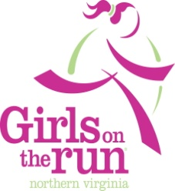
Our Mission: To educate and prepare girls for a lifetime of
self-respect and healthy living.

Girls on the Run® is a life-changing, experiential learning program for girls in grades 3 – 6. The program combines training for a 5k (3.1 mile) running event with self-esteem enhancing, uplifting workouts. The goals of the program are to encourage positive emotional, social, mental, and physical development.

Girls on the Run® meets in groups of up to 20 participants, twice weekly for a one-hour session to prepare for and complete the 5k. The program uses an innovative and fun curriculum designed exclusively for pre-teen girls to address specific life skills through the use of games, warm-ups and workouts.

Girls on the Run® participants explore the importance of being physically, mentally and emotionally healthy. They examine body image issues, stereotyping and discriminatory behaviors, as well as the importance of maintaining a realistic and healthy view of themselves.

Chesterbrook will have one section of Girls on the Run this fall coached by Mrs. Jennings and Ms. King. Other assistants are still being worked out. The group will meet on Tuesday and Thursday afternoons from 3:30 to 4:45. GOTR will begin the week of September 26th and end December 12th.

Registration for the GOTR lottery takes place from August 21st until September 18th. Please go to www.gotrnova.org by September 18th. There will be a lottery system used to select the girls that are able to participate. The fee for the program is $175. Financial aid is available.

If you have additional questions, please contact the coaches at
sjjennings@fcps.edu or mdking@fcps.edu or the PTA GOTR Representative

